Versatile Mini-Player for Spotify

Table of Contents

1. Introduction
1.1 Purpose
1.2 Intended Customers/Users
1.3 Product Scope
1.4 Outline of the document
2. Overall Description
2.1 Product Perspective
2.2 Product Functions
2.3 User Classes
2.4 Design and Implementation Constraints
3. Diagrams
3.1 UML Diagrams
3.2 ER Diagrams
3.3 DFD Diagrams
3.4 Assumptions and Dependencies
4. External Interface Requirements/Screenshots
4.1 User Interfaces
4.2 Hardware Interfaces
4.3 Software Interfaces
4.4 Communication Interfaces
5. Other Non-Functional Requirements
5.1 Performance Requirements
5.2 Safety Requirements
5.3 Security Requirements
5.4 Software Quality Attributes
5.5 Business Policies/Rules (if any)
6. Testing
6.1 Block-Box Testing
6.2 White-Box Testing
7. Conclusion
8. References

1. Introduction

1.1 Purpose
The purpose of the mini-player for Spotify is for the users to have easy time navigating and accessing their favourite songs with ease with a floating window with basic necessary commands such as: pause, previous & next song.

1.2 Intended Customers/Users
There isn't really any limitation to the range of customers this application can be used for as, the app Spotify is used by people of all sorts and is usable for people from all over different work backgrounds.

1.3 Product Scope
Scope of the product is very promising since there isn't really a very dependable mini-player for Spotify in-built into the software and is very useful for people who don't want to keep on switching windows while they are working just to access the Spotify window.

1.4 Outline of The Document
This document is organized into the following chapters to provide detailed specification:
- Chapter 1 (Introduction): Defines the purpose, scope and target audience.
- Chapter 2 (Overall Description): High level view of the product’s functions and constraints.
- Chapter 3 (Diagrams): To visualize system design.
- Chapter 4 (External Interface Requirements): Details user, hardware, and software interfaces.
- Chapter 5 (Non-Functional Requirements): Lists performance, safety, and security.
- Chapter 6 (Testing): Outlines the requirement validation plan.
- Chapter 7 (Design Architecture): Component and deployment level design.
- Chapter 8 (Product Metrics): Function Point Analysis and COCOMO estimation.

2. Overall Description

2.1 Product Perspective
This product is a standalone software application developed for an academic project. This software is made to help users have an easier time to access Spotify while working on their device as a floating window on their screen and helps them multitask easily.

2.2 Product Functions
Pause/Play:
A simple button in the floating window to help users pause or play the currently playing song.
Prev/Next:
A simple pair of buttons on the floating window to help users switch between their previously played song and playing the next song in their queue.

2.3 User Classes
API Login:
Helps user to login with their Spotify account giving access to their currently playing songs in the mini-player.
Commands:
Helps user to pause/play their current playing track or helps them to navigate through the previously played song or to skip to the next song on the queue.

2.4 Design & Implementation Constraints
The development of the software is subjected to the following limitations:

2.4.1 API Limitation
Authentication: The project is required to use “OAuth 2.0” for user authorization, as specified by Spotify’s security protocols.
Functionality: The user can only use functions permitted by the API.

2.4.2 Development Limitations
Platform: The software should be compatible with Windows (might expand the platform as it progresses) and must achieve “Always on Top” floating window effect.
Connectivity: The software requires a consistent internet connection to communicate to the Spotify servers through the API verification as it cannot function in offline mode.

2.4.3 UI Constraints
Resolution: Since it’s a mini-player, the UI must be contained in a maximum size of 300×150 pixels to ensure it does not obstruct too much of the user’s workspace.
Floating State: The application window must implement the “Always-on-Top” attribute to remain visible above other windows.

3. Use Case Requirements

3.1 UML Designs

Module 1: User Identity & Authentication
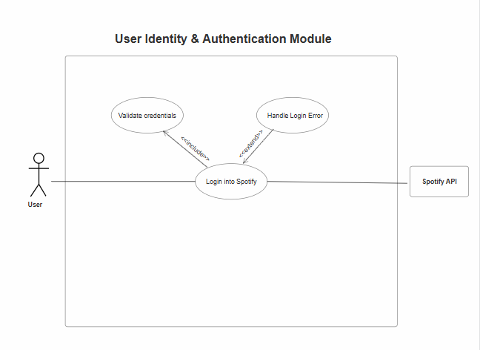
Description: This module manages the security and the session login state of the user. It ensures that only users authorized with their respective Spotify accounts can access this mini-player’s features. It validates by allowing the users to login via the Spotify API with their account credentials.
Primary Actors: User (Person accessing the mini-player)
Secondary Actors: Spotify API (External system providing authorization services)

Module 2: Playback Control
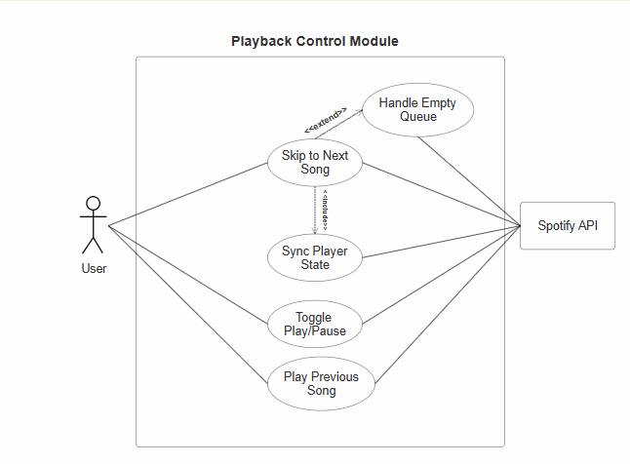
Description: This module helps with the user’s interaction with the software into music playback actions, which enables the user to play or pause the current track and navigate the songs in the queue.
Primary Actors: User (Person controlling the music)
Secondary Actors: Spotify API (Service that receives and executes the commands)

Module 3: Floating Window Management
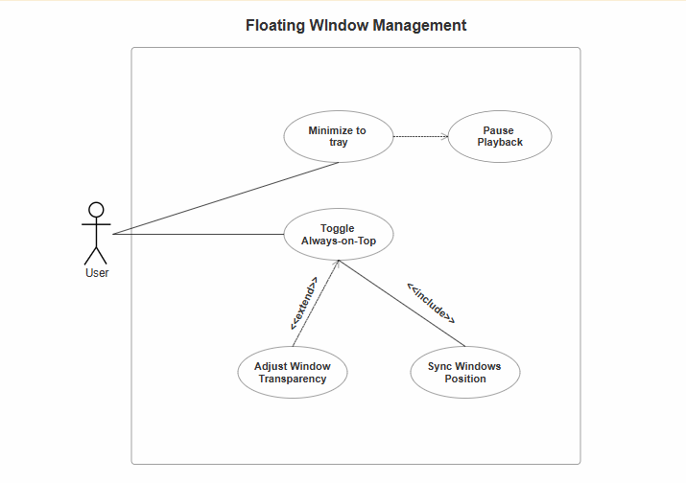
Description: This module helps with the behavior of the application in the user’s desktop environment, which allows the user to keep the mini-player “Always-on-Top” of other windows.
Primary Actors: User (Person arranging their workspace)
Secondary Actors: None.

4. Class Diagrams

4.1 User Identity & Authentication Module
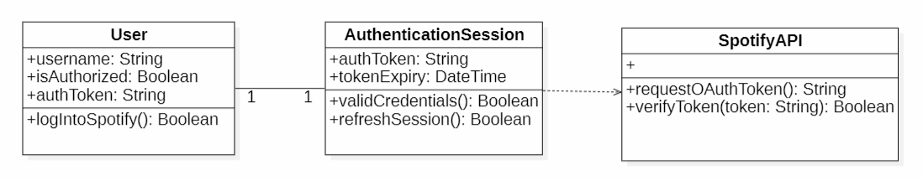
Description: This diagram shows the basic structure for managing user sessions. The user has a one-to-one relationship with their AuthenticationSession, which in turn depends on the SpotifyAPI for authentication.
- User – AuthenticationSession: A user is linked to exactly one active session.
- AuthenticationSession – SpotifyAPI: The session needs to use the API to verify credentials.

4.2 Playback Control Module
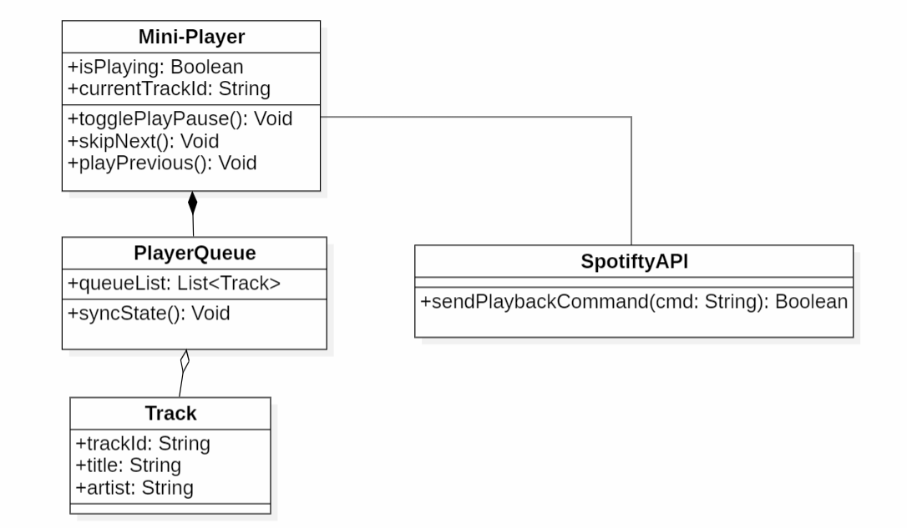
Description: This class diagram shows how the application works. The Mini-Player controls playback and contains a PlayerQueue. The software uses Spotify API to execute the commands.
- MiniPlayer – PlayerQueue: The user owns the queue; closing the player deletes the queue.
- PlayerQueue – Track: The queue holds a list of tracks.
- MiniPlayer – SpotifyAPI: The user connects to the API to send music commands.

4.3 Floating Window (UI) Management Module
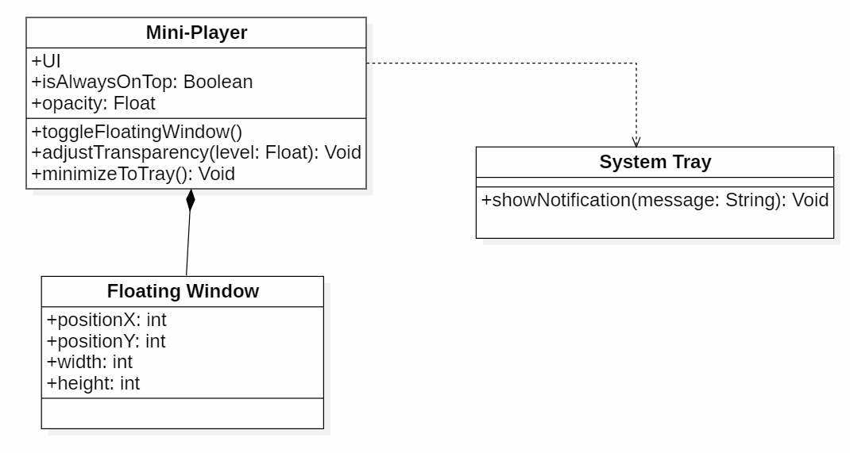
Description: This diagram focuses on the user interface. The MiniPlayer class manages UI specific attributes and contains a FloatingWindow. It depends on the SystemTray for notification functionality when minimized.
- MiniPlayer – FloatingWindow: The user application owns the physical window interface.
- MiniPlayer – SystemTray: The user uses the system tray to show notifications when minimized.

4.4 Total Application
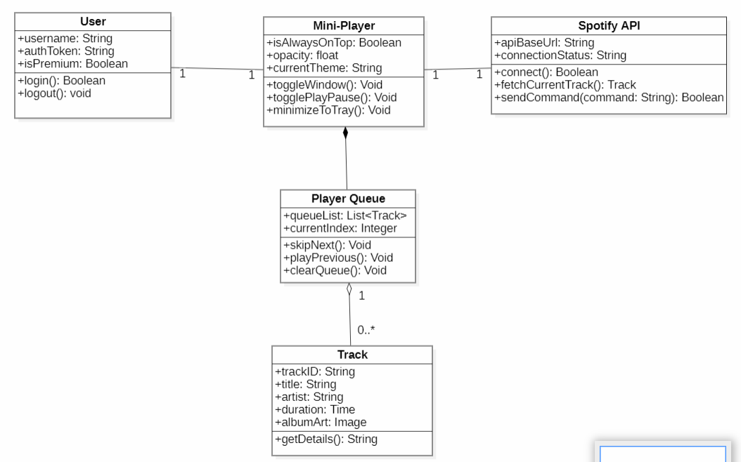
Description: Overall Class Diagram of the application consisting of all the modules.

5. State Diagrams
A State Diagram is used to model behavior of the system by showing how an object changes its state in response to events over time. Using the Playback Control Module to represent it:

5.1 Mini-Player Class State Diagram
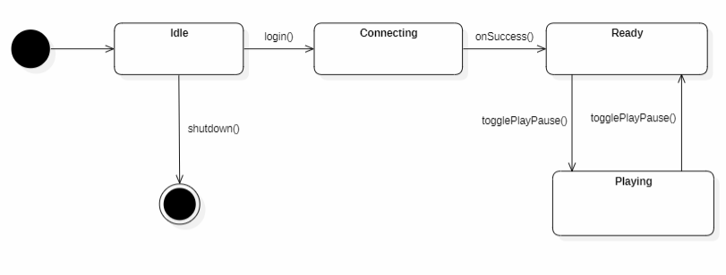
Description: This diagram tracks the operational status of the playback queue.
Key States:
- Idle: Initial state upon application launch.
- Connecting: The system is authenticating via Spotify API.
- Ready: A track is loaded and the system is awaiting user command.
- Playing/Paused: Represents the active toggle state of the audio stream.

5.2 PlayerQueue Class State Diagram
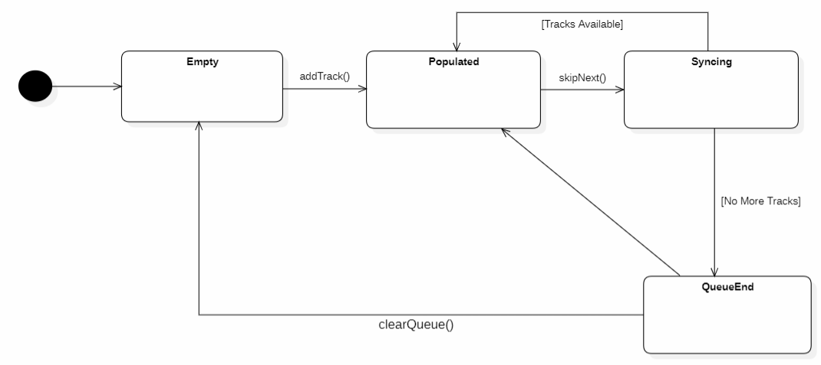
Description: This diagram models the behavior of the song list management system.
The Logic: The PlayerQueue is designed as a persistent lifecycle object. Unlike a single track that “ends”, the queue persists as long as the application is active.

5.3 Track Class State Diagram
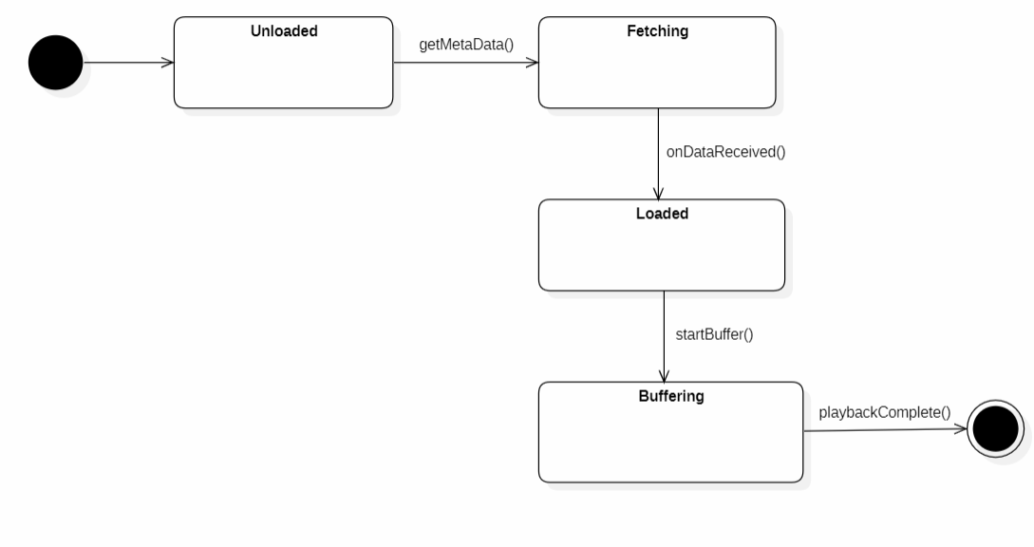
Description: Models the lifecycle of a single music data object from discovery to completion.
Key States:
- Unloaded: Initial reference stage (Tracking ID only).
- Fetching: Actively retrieving metadata (Title, Artist, Album Art) from the API.
- Loaded: Data is successfully stored in the application’s memory.
- Buffering: Preparing the audio stream for seamless playback.

6. Activity Diagram
An activity diagram is essentially an advanced version of a flow chart which shows the flow from one activity to another activity.

6.1 User Identity & Authentication Activity Diagram
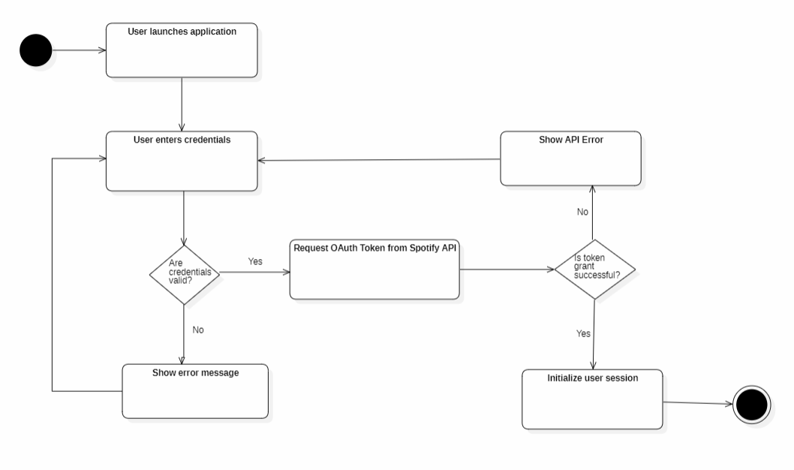
Description: This flow supplements the Authentication module by showing the decision logic for user login.
Process: It includes a Decision Node to validate credentials. If the OAuth token grant from the Spotify API is successful, the session is initialized; otherwise, an error is displayed and the user is prompted to re-enter details.

6.2 Playback Control Activity Diagram
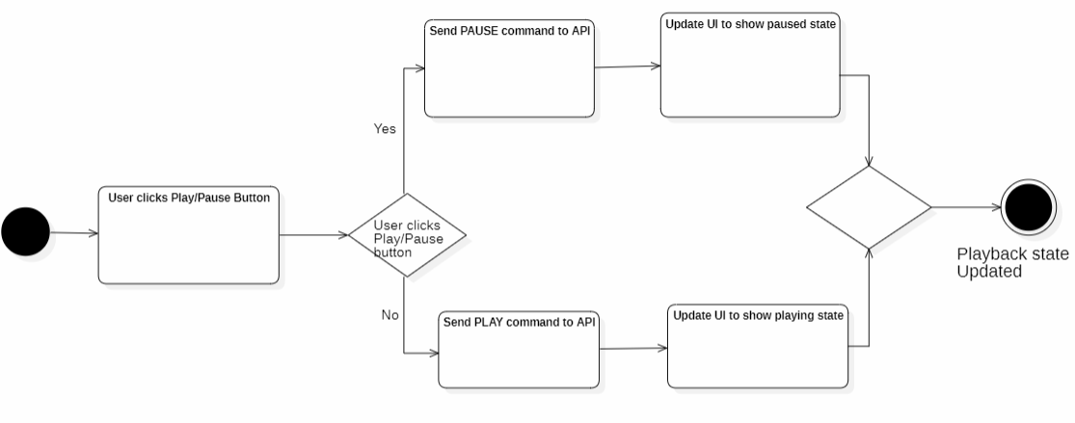
Description: This diagram illustrates the interaction when a user triggers the Play/Pause command.
Process: The system checks the current playback state via the API. If audio is playing, it sends a PAUSE command; if not, it sends a PLAY command. The flow concludes with a UI update to reflect the new state, ensuring the user has immediate visual feedback.

7. Sequence Diagram
A Sequence Diagram shows interaction between active objects in software in chronological order of messages, showing how the user interacts with the system and how the system interacts with external APIs.

7.1 User Identity & Authentication Sequence
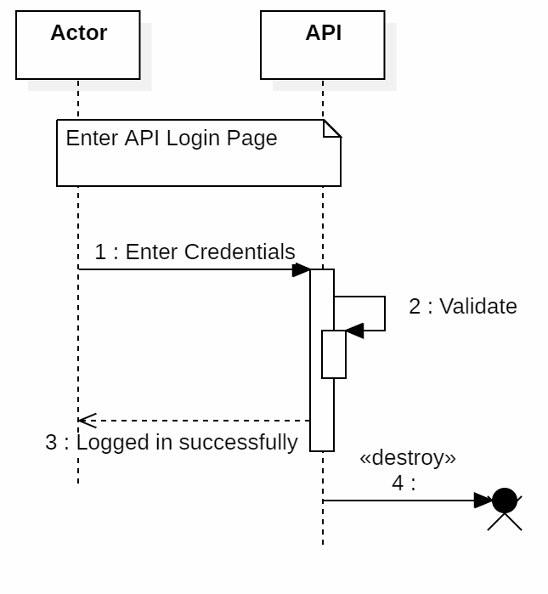
Description: Shows process of establishing a secure connection with the Spotify API.
Objects: Actor, API
Process: User enters their credentials which are in turn verified via the Spotify API before a success message is returned and the session is destroyed.

7.2 Playback Control: Skip-Next Sequence
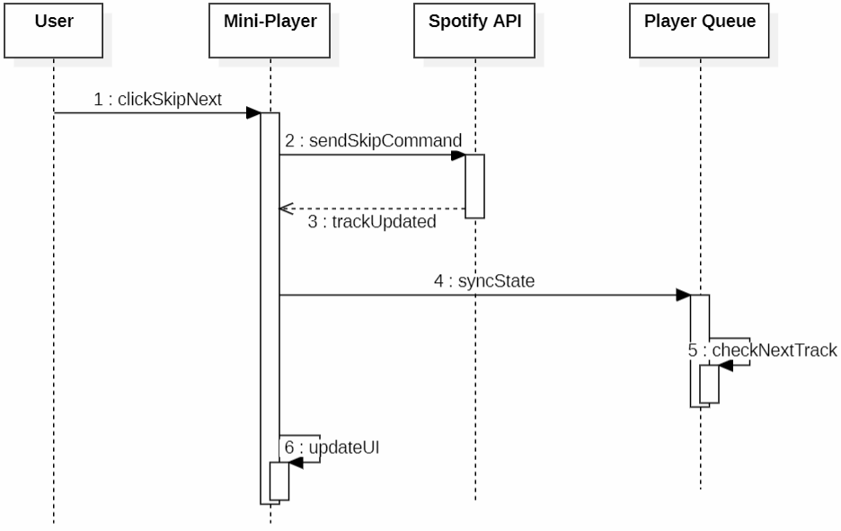
Description: Shows interaction between objects when the “Skip-Next” operation is initiated by the user.
Objects: User, Mini-Player, Spotify API, Player Queue
Process: When the user initiates the command, the mini-player sends a request to the Spotify API and the API sends the status to the Mini-Player. The player then syncs with the Player Queue, causing the mini-player to refresh its display.

8. Collaboration Diagram
Also known as a ‘Communication Diagram’, it shows how objects work together by exchanging messages between them to complete a task.

8.1 Authentication Communication
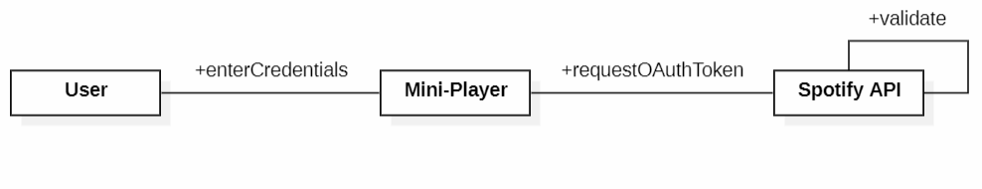
Description: Shows messages between User, MiniPlayer&Spotify API.
Structure:
- User – Mini-Player: Primary interface for login.
- Mini-Player – Spotify API: Connection for external authentication.

8.2 Playback Control Communication (Skip Next)
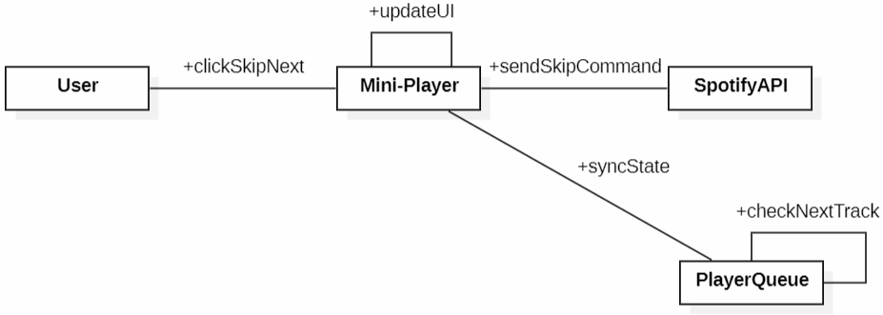
Description: Shows messages between User, MiniPlayer, SpotifyAPI&PlayerQueue.
Structure:
- Mini-Player: Acts as primary object for ‘Playback Control’, maintaining links between both Spotify API and Player Queue.
- Player Queue: Holds a link to track and fetch queue once the skip operation is successful.

9. Data Flow Diagram
Using Level 1 Data Flow Diagram to split the processes into a detailed form.

9.1 Level-1 DFD
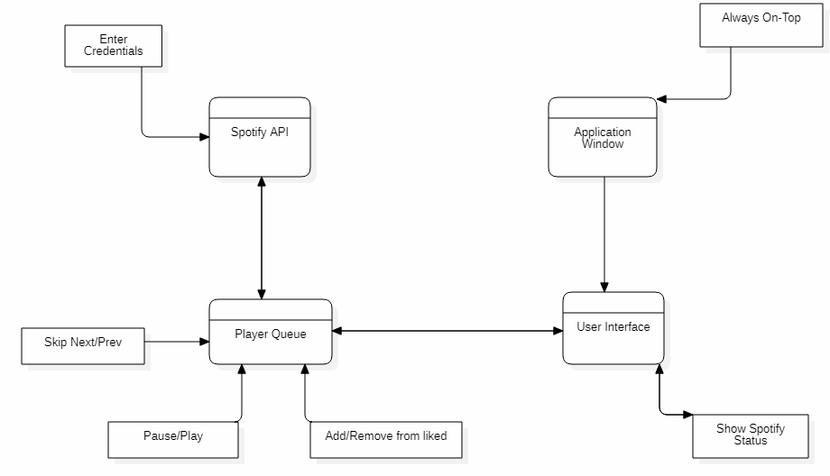
Description: Shows how the processes work in the MiniPlayer software by splitting up the processes.
Objects: Spotify API, Application Window, Player Queue, User Interface.
Key Uses:
- Spotify API: Used to validate user credentials as well as operations related to Spotify.
- Player Queue: Uses Spotify API to do basic Spotify operations such as Skip Next/Prev, Pause/Play, and Adding or removing a song from the liked list.
- User Interface: Used to display the Spotify information such as currently playing song and artist.
- Application Window: Constraint for the software application window such as Always Stay On-Top.

10. ER Diagram
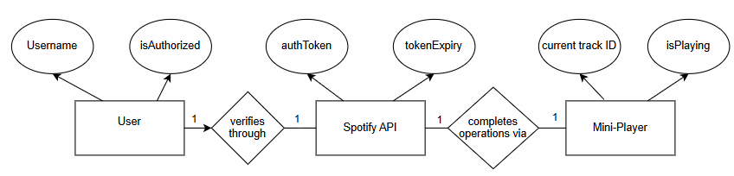
Shows how entities relate with each other and how they work together. The diagram illustrates the relationships between User, Spotify API, and Mini-Player entities, with their respective attributes.

CHAPTER – 4

External Interface Requirements

10.1 User Interfaces
- Textual description of how user interacts with the system.
- User: Person who downloaded the software to use the Spotify Mini-Player, allowed to use the basic Spotify operations.

10.2 Hardware Interfaces
Information on how the software depends on hardware. This Mini-Player software is run on PC or Laptop devices; minor requirements include Windows/Linux, CPU, and at least 4 GB RAM.

10.3 Software Interactions
- Spotify API (used for account authentication & basic operations)
- Operating System

10.4 Communication Interfaces
- LAN / Wi-Fi
- Spotify API
- HTTPS

CHAPTER – 5

Non-Functional Requirements

5.1 Performance Requirements
- Response time: The software shall respond to user’s operation in 2 seconds as it needs to be updated instantaneously.
- Battery Consumption: The software should be optimized to low power consumption.
- RAM Usage: Software should be highly efficient so as to avoid over-heating.

5.2 Safety Requirements
- Crash Handling: The software should be rebooted in case it crashes while operating.
- API Key: Make sure the API key for the particular user is secure and encrypted as it is very sensitive information.

5.3 Security Requirements
- Data Exposure: Software should display only required information.
- Authentication: Software should make sure users are logged in via their Spotify account.

5.4 Software Quality Attributes
- Reliability: Allows users to seamlessly go through their music in Spotify without interrupting their workflow.
- Usability: Very easy to use for users, since it’s a small window that’s always on top of the corner, and users can resize it as they please.

5.5 Business Policies/Rules
No specific business rules are applicable.

CHAPTER – 6

Software Testing

Module 1 — White-Box Testing
White-box testing was conducted on the Authentication module. The flow graph was constructed and cyclomatic complexity calculated using three methods.

Flow Graph
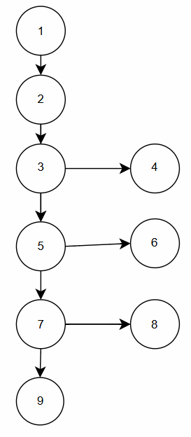
Cyclomatic Complexity:
- Method 1 – Using Regions: Total Regions = 4
- Method 2 – Using Edges & Nodes: V(G) = E – N + 2 = 11 – 9 + 2 = 4
- Method 3 – Using Independent Paths: V(G) = P + 1 = 3 + 1 = 4

Test Cases (Module 1):

Test Case | Input | Expected Output
P1 – Empty Fields | email="", password="" | Error: Fields are empty
P2 – Invalid Email | notvalid, demo123 | Error: Email needs '@' & '.'
P3 – Wrong Credentials | wrong@email.com, wrongpass | Error: Wrong email or password
P4 – Login Successful | demo@spotify.com, demo123 | Login Successful
P5 – Logout Active | session="active" | Logged Out
P6 – Logout Inactive | session="inactive" | No active session

Test Result
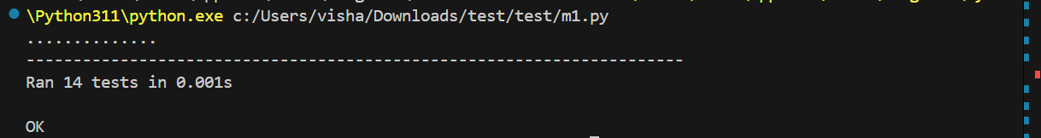

Module 2 — White-Box Testing
White-box testing was conducted on the MiniPlayer playback module.

Flow Graph
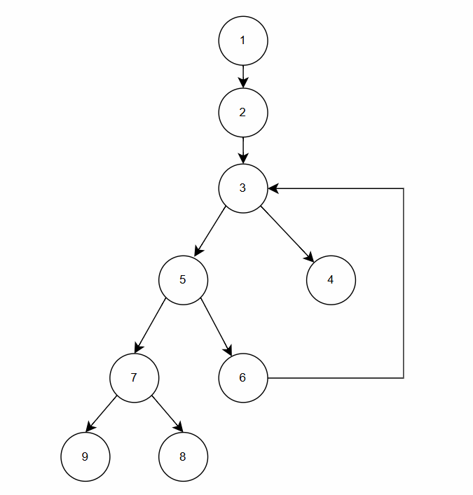
Cyclomatic Complexity:
- Method 1 – Using Regions: Total Regions = 4
- Method 2 – Using Edges & Nodes: V(G) = 11 – 9 + 2 = 4
- Method 3 – Using Predicate Nodes (3, 5, 8): V(G) = P + 1 = 3 + 1 = 4

Test Cases (Module 2):

Test Case | Input | Expected Output
Load empty list | songs=[] | No songs found
Load valid songs | ["Song A", "Song B"] | ["Song A", "Song B"]
Filter empty strings | ["", "Song B"] | ["Song B"]
Play/Pause (playing) | is_playing=True | Paused
Play/Pause (paused) | is_playing=False | Playing
Next track (no songs) | current=0, total=0 | No songs available
Next track (normal) | current=2, total=5 | 3
Next track (wrap) | current=4, total=5 | 0
Prev track (normal) | current=2, total=5 | 1
Prev track (wrap) | current=0, total=5 | 4
Progress track ended | elapsed=200, duration=200 | Track ended
Progress mid-song | elapsed=60, duration=200 | 0.3

Test Result


Black Box Testing
Module 1 – Equivalence Partitioning:

EC No. | Class | Input Condition | Valid/Invalid | Expected Output
1 | Empty Input | email="", password="" | Invalid | Error: Fields are empty
2 | Invalid Email Format | No '@' or '.' in email | Invalid | Error: Invalid email format
3 | Wrong Credentials | Valid format, wrong values | Invalid | Error: Wrong email or password
4 | Valid Credentials | demo@spotify.com / demo123 | Valid | Login Successful

Boundary Value Analysis:

TC# | Method | Input | Expected Output | Boundary
1 | update_progress | elapsed=0, duration=200 | 0.0 | Lower bound
2 | update_progress | elapsed=200, duration=200 | Track ended | Upper bound
3 | next_track | current=4, total=5 | 0 | Wrap boundary
4 | previous_track | current=0, total=5 | 4 | Wrap boundary

DESIGN ARCHITECTURE

CHAPTER – 7

Design Architecture

7.1 Component-Level Design

7.1.1 Components Overview
The system is composed of nine software components spanning all three modules.

Component | Responsibility | Provided Interface | Requires
Authentication | Manages user login, logout, OAuth token request and session validation via Spotify API. | ILogin (login(), logout(), validateEmail()) | IOAuthService from SpotifyAPI
MiniPlayer | Core playback engine. Handles play, pause, next and previous track operations. | IPlaybackControl (play(), pause(), playPause(), updateProgress()) | ISpotifyCommand; IQueueManager
FloatingWindow | Controls the always-on-top windowing behaviour of the application. | IWindowControl (show(), hide(), resize(), setPosition()) | IWindowAPI; ISystemTray
SpotifyAPI | External service layer. Handles OAuth 2.0 tokens and executes playback commands. | IOAuthService, ISpotifyCommand | None – external
PlayerQueue | Manages the ordered list of songs. Provides next/previous navigation. | IQueueManager (getNext(), getPrevious(), loadSongs()) | ITrackData from Track
Track | Holds metadata for an individual song (title, artist, duration, album art). | ITrackData (getTitle(), getArtist(), getDuration()) | ILogin from Authentication
SystemTray | Manages the system tray icon and desktop notifications when minimised. | ISystemTray (showTrayIcon(), hideTrayIcon(), sendNotification()) | None

7.1.2 Dependency Relationships
- Authentication depends on SpotifyAPI to request and validate OAuth 2.0 tokens before a user session can be established.
- MiniPlayer depends on SpotifyAPI to send every playback command and retrieve the current playback state.
- MiniPlayer depends on PlayerQueue to determine next/previous track indices and load the song list on startup.
- PlayerQueue maintains an association with the Track component – each entry in the queue is a Track object.
- FloatingWindow depends on OSWindowManager to apply the always-on-top window attribute.
- FloatingWindow depends on SystemTray to send desktop notifications and manage the tray icon.

7.1.3 Component Diagram
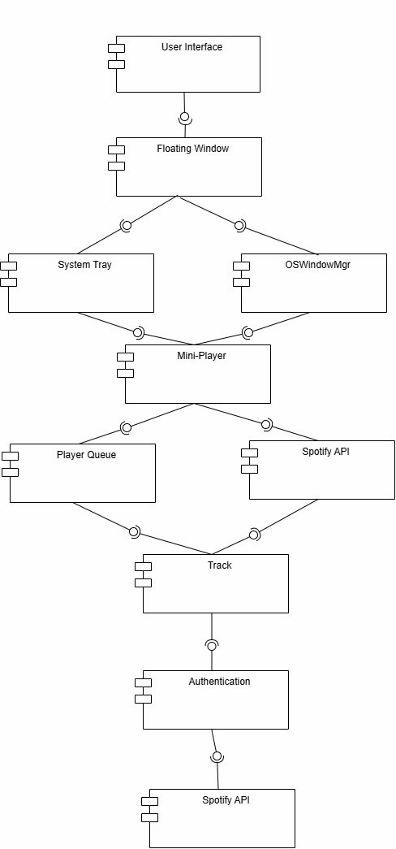
The User Interface provides the top-level entry point and delegates windowing to the Floating Window component. Floating Window requires both System Tray and OSWindowMgr. The Mini-Player sits at the core, requiring both the Player Queue and Spotify API. Player Queue links to Track, which requires Authentication, which in turn requires the Spotify API.

7.2 Deployment-Level Design

7.2.1 Physical Nodes
User’s PC / Laptop:
The primary node where the entire application runs locally.Hosts all components across all three modules. Requires Windows OS, a standard CPU, and a minimum of 4 GB RAM.
Spotify Remote Server:
The external Spotify cloud infrastructure. Hosts the SpotifyAPI component and is accessed exclusively through Spotify’s published Web API over HTTPS.

7.2.2 Communication
Source Node | Target Node | Protocol / Link
User’s PC / Laptop | Spotify Remote Server | HTTPS / Spotify Web API over Wi-Fi or LAN

7.2.3 Deployment Diagram
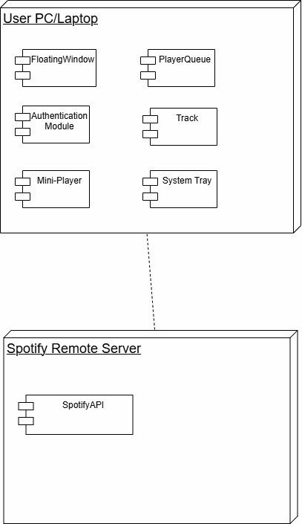
All components from every module are consolidated on the User’s PC node, with only the SpotifyAPI deployed on the remote Spotify server node. Communication between nodes uses HTTPS over Wi-Fi or LAN.

PRODUCT METRICS

CHAPTER – 8

Product Metrics

8.1 Function Point Analysis (FPA)
Function Point Analysis measures the functional size of the Spotify Mini-Player based on its information domain values and system complexity. The calculation follows three steps: counting the five domain values (UFP), computing the Complexity Adjustment Factor (CAF), and multiplying to get the final Function Points (FP).

8.1.1 Step 1 — Information Domain Values (UFP)

Information Domain Value | Count | Weight (Simple) | Subtotal | Examples
External Inputs (EIs) | 4 | 3 | 12 | Login, Play/Pause, Next, Previous
External Outputs (EOs) | 3 | 4 | 12 | Now Playing, Status, Error messages
External Inquiries (EQs) | 2 | 3 | 6 | Fetch current track, Fetch queue
Internal Logical Files (ILFs) | 1 | 7 | 7 | PlayerQueue (song list)
External Interface Files (EIFs) | 1 | 5 | 5 | Spotify API
UFP (Count Total) |  |  | 42

8.1.2 Step 2 — Value Adjustment Factor (VAF / CAF)
Each of the 14 general system characteristics is rated on a scale of 0 (No influence) to 5 (Essential). CAF = 0.65 + (0.01 × ΣFi)

# | Factor | Rating (0–5) | Justification
1 | Reliable backup and recovery | 1 | No local data to recover
2 | Specialized data communications | 3 | Standard HTTPS to Spotify API
3 | Distributed processing functions | 3 | App local, Spotify remote
4 | Performance critical | 4 | 2s response time required (SRS)
5 | Existing operational environment | 3 | Runs alongside other apps
6 | Online data entry required | 5 | Login + live commands via API
7 | Input transaction built over multiple screens | 1 | Single screen, single-click only
8 | ILFs updated online | 4 | PlayerQueue updates live from API
9 | Complexity of inputs, outputs, files, inquiries | 2 | Simple buttons, basic track info
10 | Internal processing complexity | 2 | OAuth logic present but straightforward
11 | Reusable code design | 1 | Academic project, not built for reuse
12 | Conversion and installation in design | 2 | Basic Windows install, no migration
13 | Multiple installations across organizations | 0 | Single-user personal app
14 | Ease of use and change facilitation | 5 | Core purpose of the product
ΣFi (Total) |  | 36

8.1.3 Step 3 — Function Points (FP)
CAF = 0.65 + (0.01 × 36) = 0.65 + 0.36 = 1.01
FP = 42 × 1.01 = 42.42 Function Points
The Spotify Mini-Player has a functional size of 42.42 FP. The CAF of 1.01 reflects a system of near-average complexity, requiring reliable real-time communication with an external API and a strong focus on ease of use.

8.2 COCOMO Model Estimation
The Constructive Cost Model (COCOMO) is used to estimate the effort, development time, and staffing requirements for the Spotify Mini-Player based on its estimated Lines of Code (LOC).

8.2.1 Overview of COCOMO
COCOMO (Constructive Cost Model) is a regression model based on the number of Lines of Code (LOC). It is a procedural cost estimation model proposed by Barry Boehm in 1970, based on the study of 63 projects.
- Effort: Amount of labor (staff) required to complete a task, measured in person-months.
- Schedule: Amount of time required for completion, proportional to effort, measured in weeks or months.

8.2.2 Project Category
Boehm categorizes software projects into three types:

Type | Description | Example
Organic | Small team, well-understood problem, nominal team experience. | Simple utilities, small tools
Semi-detached | Mixed team size and experience, between Organic and Embedded. | Compilers, embedded systems
Embedded | Highest complexity and creativity; large team, experienced developers required. | Real-time OS, flight systems

The Spotify Mini-Player is classified as an Organic project, given its small team size, well-defined scope, straightforward API integration, and a problem domain that is well understood.

8.2.3 Types of COCOMO Models
- Basic COCOMO: Uses predicted software size (KLOC) alone to estimate development effort. Suitable for quick, rough calculations.
- Intermediate COCOMO: Uses KLOC plus 15 subjectively assessed cost drivers to refine the effort estimate.
- Advanced (Detailed) COCOMO: Extends the intermediate model with phase-based cost driver adjustments at module, component, and system levels.

8.2.4 Basic COCOMO Model — Formulas
Effort (E) = A × (KLOC)^B [Person-Months]
Time (T) = C × (Effort)^D [Months]
Persons Required = Effort / Time

Software Project | A | B | C | D
Organic | 2.4 | 1.05 | 2.5 | 0.38
Semi-Detached | 3.0 | 1.12 | 2.5 | 0.35
Embedded | 3.6 | 1.20 | 2.5 | 0.32

8.2.5 COCOMO Estimation for Spotify Mini-Player
Based on code analysis of Module 1 (Authentication) and Module 2 (MiniPlayer/Playback), the estimated size of the Spotify Mini-Player project is approximately 0.5 KLOC (500 lines of code). The project is classified as Organic.

Effort Calculation (Organic Mode):
E = 2.4 × (0.5)^1.05 = 2.4 × 0.483 = 1.16 Person-Months
Development Time Calculation:
T = 2.5 × (1.16)^0.38 = 2.5 × 1.059 = 2.65 Months
Persons Required:
Persons Required = 1.16 / 2.65 = 0.44 ≈ 1 Person

Summary of Results:

Parameter | Value
Estimated Project Size | 0.5 KLOC (500 LOC)
Project Category | Organic
Effort (E) | 1.16 Person-Months
Development Time (T) | 2.65 Months (~11 Weeks)
Persons Required | 1 Person

8.2.6 Intermediate COCOMO Model
The Intermediate COCOMO model refines the estimate by incorporating 15 cost driver attributes. The product of all ratings gives the Effort Adjustment Factor (EAF).
Effort (E) = (A × (KLOC)^B) × EAF
Time (T) = C × (Effort)^D

The 15 cost drivers are grouped into four attribute categories:
(i) Product Attributes:
- Required software reliability extent
- Size of the application database
- Complexity of the product
(ii) Hardware Attributes:
- Run-time performance constraints
- Memory constraints
- Volatility of the virtual machine environment
(iii) Personnel Attributes:
- Analyst capability
- Software engineering capability
- Applications experience
- Virtual machine experience
- Programming language experience
(iv) Project Attributes:
- Use of software tools
- Application of software engineering methods
- Required turnabout time
- Required development schedule

For the Spotify Mini-Player, most cost drivers are rated at Nominal level, resulting in an EAF close to 1.0. This confirms that the Basic COCOMO estimate of approximately 1.16 person-months is a reasonable and reliable figure for this project.

Conclusion:
The COCOMO analysis confirms that the Spotify Mini-Player is a small-scale, organic-type project with low complexity. The estimated development effort is approximately 1.16 person-months, with a projected completion time of roughly 2.65 months for a single developer. These estimates align well with the academic project scope and the Function Point Analysis result of 42.42 FP.

